
RESEARCH BRIEFING:
Female Veteran’s Experiences of the Service Justice System Response to Sexual Violence

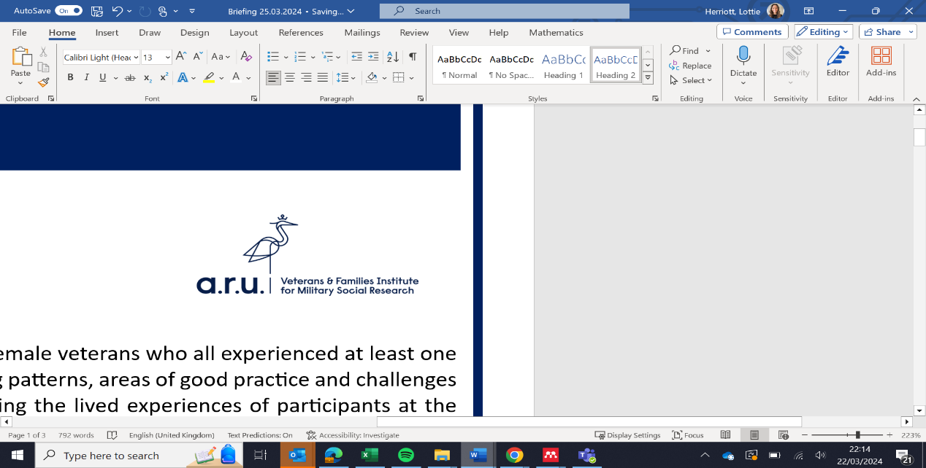

Executive summary:
Drawing on the findings of 8 in-depth qualitative interviews with UK female veterans who all experienced at least one form of sexual victimisation during their service; we explored recurring patterns, areas of good practice and challenges in the service justice system [SJS] response to sexual offending. Placing the lived experiences of participants at the heart of our analysis, the following briefing outlines key learning points and implications for ongoing SJS reform debates.

Project Background:
In March 2018, retired senior Crown Court Judge Shaun Lyons, formally recommended that rape (and potentially other serious sexual offences) should be tried in the UK’s civilian criminal justice system [CJS], as opposed to the military’s independent service justice system [SJS]. Though eventually rejected by the MOD in December 2021, the decision prompted high-profile scrutiny of the way in which the SJS deals with sexual offences cases, with suggestions that investigations lacked expertise, conviction rates were inadequate, and victim-survivors were often left unsupported. Amidst this debate, however, the service justice response to sexual offending in the UK military has until now, received scant academic attention. As such, there remains a paucity of knowledge and understanding about both victim-survivor perceptions and experiences of the SJS response to sexual offending in the UK armed forces, with much of the available literature on MSV coming from the US or Canadian context. The current project sought to fill this important gap in the knowledge base, foregrounding victim-survivor voices to identify both areas of good practice and challenges as discussed throughout this briefing.

The sample:
Our final sample reflected a range of military backgrounds, services, and ranks; with women from the Army (5), Navy (2) and Air Force (1) represented, ranging in rank from Private through to Lieutenant and serving between 3 and 20 years between the 1970s and 2021. Of the final sample, three reported having been raped during service, six sexually assaulted and all reported frequent and repeated sexual harassment during their military careers.

Findings: Trust and Credibility
- Assumptions about and perceptions of the SJS played a significant role in victim-survivors’ trust in and willingness to engage with the SJS process.
- Negative perceptions about the efficacy of the SJS were common, including a lack of trust in the expertise of service police, a perception that investigations lacked impartiality, a feeling that nothing would be done to support victim-survivors, and a perception that offenders would be protected rather than punished.
- Lack of trust in the military response was often linked to secondary experiences, whereby servicewomen had witnessed other serving women report sexual victimisation in the military, only to be met with inadequate and ineffective responses. This prompted a widespread reluctance to report.

Findings: Cultural Challenges
- Our findings illustrate concerning adherence to rape mythology and victim-blaming narratives throughout the SJS, from initial disclosure through to the narratives presented at court martial.
- When participants did disclose, responses regularly focused only the potential impact on the accused (e.g. suggestions that you could ruin their career) rather than a stance of belief. This resulted in frequent secondary victimisation and isolation of complainants, and perpetuated impunity for perpetrators.
- Participants described being treated “like a leper,” “labelled as a troublemaker” and a “bad egg” for making a report, whilst perpetrators were seemingly largely protected by military social codes.
- Hostile responses were not limited to social conditions but also professional impacts, enforced through military hierarchies. Perhaps most concerning, was that four participants were investigated or threatened with investigations of their own conduct when reporting. Punishment threats were common.

Findings: Operational Issues
- Lack of support and responsiveness: Throughout investigation and court martial process, several women reported being ill-informed on the process, poorly updated as to progress, and not offered or unaware of available support.
- Poor treatment during interviews: Victim-survivors shared various aspects that culminated in unsupportive atmospheres, including but not limited to not knowing what to expect, no prior introduction to those conducting interviews, and not having an advocate or support figure in the room. The tone of interviews was also regularly perceived as victim-blaming.
- Investigations: Several participants reported concerns around the quality of investigations, including perceptions that investigators lacked independence, or military superiors closed ranks to create a culture of silence around sexual misconduct.
- Challenges at court martial: Several participants reported difficult victim-blaming narratives being presented during court martial, with the suggestion that focus was awarded to the character and credibility of the victim-survivors. A perceived lack of support for victim-survivors/complainants was also a significant challenge.
- Secondary trauma: For some their experience of pursuing a sexual offense was secondarily traumatising, with some characterising it as worse than the initial incident (e.g. ‘Because the way they have treated me, in a way has been worse than what actually happened.’)

Findings: Structural Issues
- The small, close-knit military community posed a challenge for anonymity, confidentiality, and discretion in MSV investigations.
- Though policy was seen as important, several victim-survivors felt that even where policy existed, this was often not utilised to support them in practice. Whilst our findings cannot comment on the impact of 2022 policy revisions, what was clear from our interviews was a widespread scepticism amongst our participants about the meaningfulness and practical implementation of policy. Interestingly one participant reported MSV both twenty years ago and four years ago but suggested very little practical change despite significant policy attention and reform over the course of this period. Effective implementation is pivotal to ensuring the effectiveness of policy.
- Participants questioned the implications of not following policy, highlighting that often a clear asymmetric power differential exists between the individual reporting MSV and the individual leading the investigations.
- Jurisdictional decisions reported by our participants were often imprecise and seemingly misapplied. For example two participants originally reported to the civilian police but were told that the civilian police did not have jurisdiction and their cases transferred to the military police.

Findings: Learning from Perceived Good Practice
- Several participants were aware that convictions for sexual offences are unlikely, and suggested that instead, being believed and treated with support and compassion were more important than achieving a criminal conviction.
- One participant attended a civilian SARC with military police officers after reporting and commented on the suitability of the setting and support she felt.

Future Research Priorities:
- Survey serving personnel to understand trust in the SJS and willingness to engage, following the extensive 2022 reform efforts.
- Conduct an in-depth analysis of the DCSU, including gaining insights into the quality and independence of investigations, as well as serving personnel’s attitudes and perceptions towards the unit and their willingness to report.
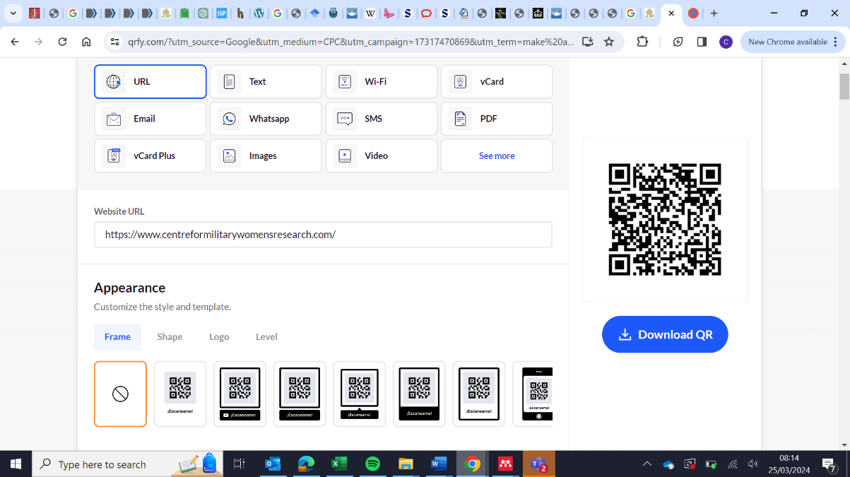
- Undertake court observation research to ascertain areas of good practice and challenges in the court martial response to sexual offending.
- Work together with defence and civilian stakeholders, to gain an understanding of what frontline professionals see as areas of good practice, challenges, and practical considerations for the SJS response to sexual offending.
Dr Charlotte Herriott, Abigail Wood, Dr Lauren Godier-McBard, Professor Matt Fossey

